**Step 1:**

Log in to Azure portal with [sudherson@1cloudhub.com](mailto:sudherson@1cloudhub.com)

Choose directory as 1cloudhub

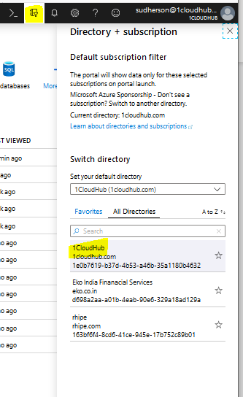

**Step 2:** Search for CDN in the search box, and choose CDN profiles

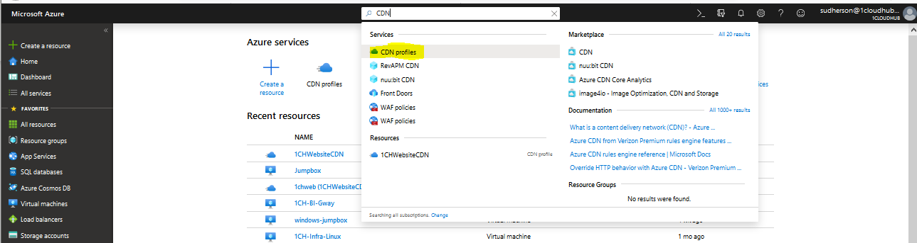

**Step 3: Select 1CHWebsiteCDN and click Purge**

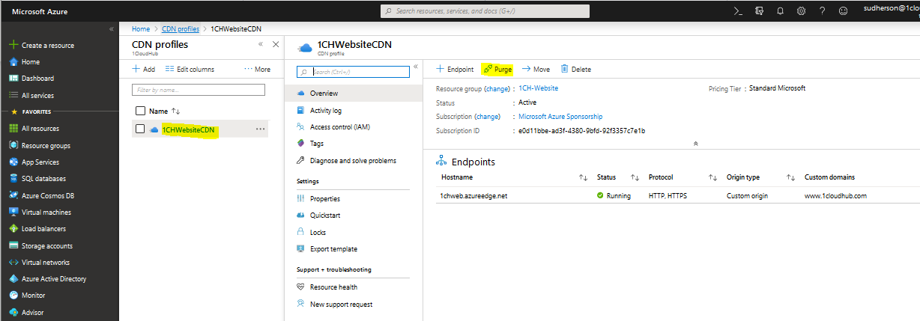

**Step 4:** Choose endpoint as **1chweb.azureedge.net** and select checkmark on Purge all. Then click Purge.

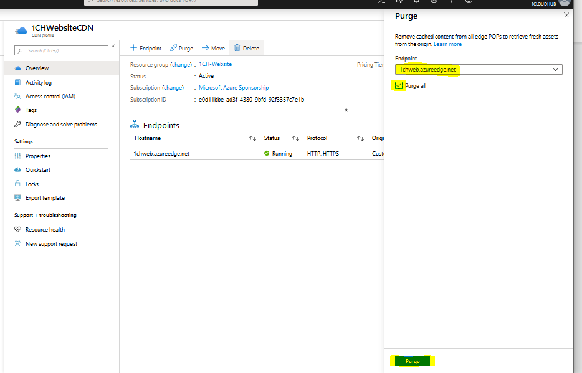

**Step 5:** Purge action will take 2-3 mins to complete.

